Optimizing the Spontaneous-Emission of Far-UVC Phosphors

Ohad Segal^{†1}, Avner Shultzman^{†1,2}, Yaniv Kurman¹, and Ido Kaminer^{1,}*

¹ Solid State Institute, Technion – Israel Institute of Technology, 32000 Haifa, Israel
² The Weizmann Institute of Science, 76100 Rehovot, Israel
†O. Segal and A. Shultzman contributed equally to this work.
*e-mail: kaminer@technion.ac.il

Supplementary Material

S1. Optimization of multilayered nanostructures | 2
S2. FDTD simulations of spontaneous emission from multilayered nanostructures | 3
S3. Optical Properties of Silica at $λ=172\left[nm\right]$ | 4
S4. References | 5

In this Supplementary Material, we present the methodology we used for designing and validating the optimized multilayered nanostructures. In the first part (section S1), we formulate the optimization problem, including the choice of constraints and figures of merit. In the second part (section S2) we describe how to validate the resulting structure properties using FDTD simulations. In the third part (section S3) we describe the optical properties of fused silica at the wavelength of the input radiation.

S1 Optimization of multilayered nanostructures
Our work presents an optimization approach that optimizes the efficiency of an active multilayered nanophotonic device. This section describes the optimization problem. We note that a similar approach can be applied to different figures of merit.
In the case studied here, the structure’s thicknesses constitute the degrees of freedom in the optimization procedure. We can also add the indices of refraction of the layers as additional degrees of freedom if considering multiple materials of varying indexes. When the indices are fixed, a planar nanostructure with $N$ layers can be represented by a vector of thicknesses $d∈R_{+}^{N}$. The structure that maximizes the efficiency is obtained by solving the following constrained maximization problem, with $I$ and $J$ constraints in the form of equalities and inequalities, respectively:
 | $$d^{⋆}=\arg{\max_{d∈R^{N}}{η\left(d\right)}} \\ s.t. g_{i}\left(d\right)=0, ∀i∈\left[1,I\right] \\ h_{j}\left(d\right)≤0, ∀j∈\left[1,J\right]$$ | $$\left(S1\right)$$
where $η$ is the efficiency of the structure represented by $d$. In addition, $g_{i}\left(∙\right) ∀i∈\left[1,I\right]$ and $h_{j}\left(∙\right) ∀j∈\left[1,J\right]$ are equality and inequality constraints, respectively. The constraints may arise from manufacturing limitations, such as a lower bound on the layers' thicknesses or an upper bound on the overall phosphor thickness due to the light’s attenuation. We denote by $d^{⋆}$ the solution to the above problem.
Our algorithm uses an off-the-shelf implementation of the interior-point method [1]. We use this method in combination with geometrical constraints, in a way that can be directly applied to various applications. To determine the number of layers in the final structure, we repeat the optimization with different numbers of layers and retain the structure that achieved the optimal objective. Also, since the optimization problem is generally nonlinear (leading to multiple local minima), we perform the optimization process multiple times with randomly generated initial thicknesses. The thicknesses that achieve the optimal objective over all random initializations determine the chosen structure.
S2 FDTD simulations of spontaneous emission from multilayered nanostructures
We rely on Lumerical’s FDTD solver to perform the numerical simulation. Our theoretical model assumes a uniform and infinite structure along the XY plane. We use this symmetry to reduce our generally 3D simulations to 2D grids with perfectly matched absorbing boundary conditions [2-3]. The theoretical model further assumes that the emitters are randomly distributed within the phosphor layers. We perform three simulations for each emitter location to simulate the emission from a multilayered structure with randomly oriented emitters. In each of the three simulations, the emitter is oriented along a different axis. The results are then averaged to model an isotropic distribution of emitters [4]. In every simulation, the field generated by the emitter is measured on a plane far enough (several wavelengths) outside the structure, which can then be projected to the far field. This far field pattern is highly dependent on the optical surrounding of the emitters (Purcell effect).
To calculate the emission rate, we perform a weighted average of the simulation results for the locations in which there is phosphor material. The weights are determined by a decaying probability of the penetration depth of the incoming radiation. Typically this decay probability has an exponential tail that depends on various mechanisms of elastic and inelastic scattering of the radiation. Finally, we normalize the resulting graph relative to the result of a bulk structure.
Our simulation files are also available on our GitHub (ref. 21 in the main text).

S3 Optical Properties of Silica at $λ=172\left[nm\right]$
We consider dielectric materials with high UV transmission such as JGS1 fused silica. The absorption coefficient at 172 [nm] is $22∙{10}^{-9} \left[nm^{-1}\right]$, which can be extracted from the transmittance curve using Beer–Lambert law. The transmittance curve of a $10 [mm]$ fused silica can be accessed at [5] and is shown in figure S1.
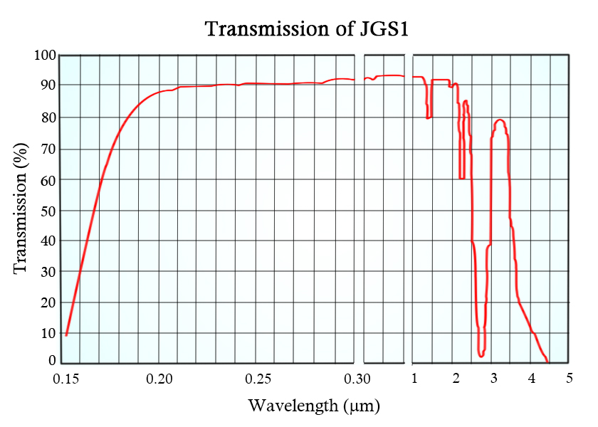
Figure S1. Transmission curve of JGS1 [5].
S4 References
1. Wright S, Primal-dual interior-point methods, Society for Industrial and Applied Mathematics, 1997.
2. J. P. Berenger, Perfectly Matched Layer (PML) for Computational Electromagnetics. Morgan & Claypool Publishers, 2007.
3. https://support.lumerical.com/hc/en-us/articles/360034382674-PML-boundary-conditions-in-FDTD-and-MODE
4.
https://support.lumerical.com/hc/en-us/articles/1500006080761-Incoherent-unpolarized-dipole
5. https://shalomeo.com/jgs1-datasheet-shalomeo.html

